|  |
| --- |
| *Homemade Bloody Mary Mix* |
| http://assets.goop.com/temp/issue-title-lines_1.png |

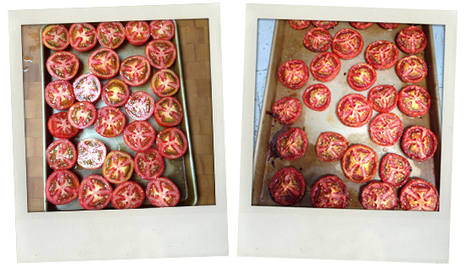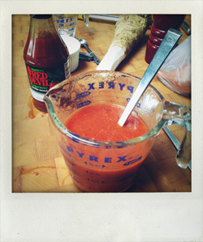

This recipe makes a fresh and delicious Bloody Mary mix.

|  |
| --- |
| http://assets.goop.com/temp/10x10.png |

*ingredients   
makes about 1.5 cups*

|  |
| --- |
| http://assets.goop.com/temp/10x10.png |

http://assets.goop.com/temp/issue-break.png

|  |
| --- |
| http://assets.goop.com/temp/10x10.png |

* [18 slow-roasted tomato halves](http://www.goop.com/recipes/smallbites/roasted-tomatoes)
* juice of 1/2 lemon
* 3 teaspoons fresh horseradish, grated
* 1 teaspoon of cayenne pepper sauce to taste (or any hot sauce of your choice)
* 1 heaping tablespoon of worcestershire sauce
* 1/2 teaspoon of fresh pepper
* dash of celery seed
* pinch of salt

|  |
| --- |
| http://assets.goop.com/temp/10x10.png |

http://assets.goop.com/temp/issue-break.png

|  |
| --- |
| http://assets.goop.com/temp/10x10.png |

*preparation*

|  |
| --- |
| http://assets.goop.com/temp/10x10.png |

1.Blend slow-roasted tomatoes on low in a Vitamix. 

2.Strain into a jug (save the strained part for the Healthy Chicken Parm below). 

3.Add the rest of the ingredients and mix. This keeps in the fridge for up to a week. 

|  |
| --- |
| http://assets.goop.com/temp/issue-title-lines_1.png |
| *Bloody Mary* |
| http://assets.goop.com/temp/issue-title-lines_1.png |

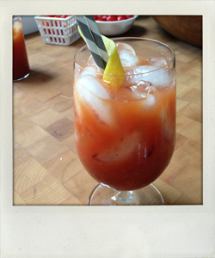

|  |
| --- |
| http://assets.goop.com/temp/10x10.png |

*ingredients   
makes about 1 drink*

|  |
| --- |
| http://assets.goop.com/temp/10x10.png |

http://assets.goop.com/temp/issue-break.png

|  |
| --- |
| http://assets.goop.com/temp/10x10.png |

* 2oz or 2 jiggers of vodka (Kettle One is the best for Bloody Marys)
* 1 lemon wedge for garnish
* handfuls of ice (to fill the glass)
* about 1 cup of Bloody Mary mix

|  |
| --- |
| http://assets.goop.com/temp/10x10.png |

http://assets.goop.com/temp/issue-break.png

|  |
| --- |
| http://assets.goop.com/temp/10x10.png |

*preparation*

|  |
| --- |
| http://assets.goop.com/temp/10x10.png |

1.Fill the glass with ice. Add 2oz of vodka and about 1 cup of mix. Squeeze a lemon wedge into the glass and drop it in. Mix and drink.